**Temasek Polytechnic**

**School of Informatics and IT**

**Diploma in Information Technology (IT)**

Software Requirement Specifications (SRS)

**Project Particulars**

|  |  |
| --- | --- |
| **Tutor** | Qi Yutao |
| **Class** | P01 |
| **Project Title** | Delonix Regia Hotel Management System |

**Project Team’s Particulars**

|  |  |
| --- | --- |
| **Matric Number** | **Student Name** |
| 1601553I | Yip Xiu Han |
| 1603625C | Ch’ng Wai Kit Wesley |
| 1601705E | Qamarul Fattah Bin Hamdan |

**Revision History**

|  |  |  |  |
| --- | --- | --- | --- |
| **Date** | **Version** | **Description** | **Author** |
| <dd/mm/yy> | <x.x> | <details> | <name> |
| 13/11/17 | 1.0 | Initial Draft |  |
|  |  |  |  |
|  |  |  |  |

**Table of Contents**

**DISTRIBUTION OF WORKLOAD** **4**

**OVERVIEW OF REQUIREMENTS** **4**

System Functions 4

User Characteristics 5

General Constraints 5

Functional Requirements 5

Data Requirements 8

User Interface Requirements 10

Interface with Other Systems 12

Assumptions 13

**OPERATIONAL AND QUALITY REQUIREMENTS** **13**

Operating Environment 13

Development Constraints 14

Performance 14

Availability 15

Security and Access Control Requirements 15

**SPECIAL REQUIREMENTS** **16**

**REFERENCES** **16**

# **DISTRIBUTION OF WORKLOAD**

*[Determine which members of the team will be responsible for which areas in the requirement gathering process. Individual’s responsibilities should be clearly spelt out.] (Write who wrote which one)*

|  |  |
| --- | --- |
| **Requirement Gathering** | **Members** |
| Room Availability & Booking Module | Wesley |
| User Creation & Login Module | ALL |
| Housekeeping & Staff Management Module | Qamarul |
| Reporting Module | Xiu Han |
| User Characteristics | Wesley |
| General Constraints | Xiu Han, Wesley |
| Functional Requirements | ALL |
| Data Requirements | ALL |
| User Interface Requirements | Qamarul |
| Interface with other Systems | Xiu Han |
| Assumptions | ALL |
| Operating Requirements | Xiu Han, Wesley |
| Development Constraints | ALL |
| Performance | Xiu Han, Wesley |
| Availability | ALL |
| Security and Access Control Requirements | Wesley |
| Special Requirements | Xiu Han |

# 

# OVERVIEW OF REQUIREMENTS

## **System Functions**

*[List and give a brief description of the functions of the systems that are to be implemented.] (Login, Logout, Room Booking/Reservation, Housekeeping, Report, User Account)*

**Room availability and Booking Module**

* This module should allow the staff at the front desk to take note of the guest details when guests are registering for a room in the hotel.
* Tracks the reservations made by customers. Also tracks the status of rooms, if the room is available at specific times.
* If a room is occupied, it will record the guest’s information as well as their check-in and checkout times.
* Allows administration or reception staff to edit existing guest records. Examples of information to be edited are room changes, guest names and the number of adults and children that are in the room.

**User Creation and Login Module**

* This module should allow the hotel system administrators to create, retrieve, update and delete user accounts for both the end users and management users.

**Housekeeping and Staff management Module**

* This module should allow the owner of the hotel to keep track of records of the staff including their details as well as respective roles.

**Reporting Module**

* This module should be able to help generate different types of reports for the hotel.

## **User Characteristics**

*[Describe the characteristics of the users of the systems and the role they play.]*

*(Who are the users of the system, E.g. Receptionist, System Administrator, Management)*

**End Users**: Helps customers to book, check in and checkout of hotel. Reception Staff work at the front counter: Only has access to parts of the reporting module but has full access to the Room Availability and Booking Module.

**Management Users**: Manages the hotel operations and also has access to all 3 modules (Room Availability and Booking Module, Housekeeping and Staff Management Module, Reporting Module).

**Hotel Administrators**: Have access to all 3 modules, including the User Account and Login module. Module is able to create accounts for new staff and new users.

## **General Constraints**

*[Highlight any constraints such as dependency on other systems, existing hardware/software platform or technology, restriction due to organization policy or legal requirements.] (Project deadline, budget)*

* **Limited Budget:** Final budget of S$70,000 allocated for developing the software.
* **Low-end Hardware:** Only one computer at the front desk will be running the software, computer is running windows xp support package tool, 1gb ram, 160gb hard disk.
* **Slow Connection:** Connection to the hotel module services might also be slow, seeing as it is connected to a shared broadband that is also simultaneously used to maintain the hotel’s blog website.
* **Limited Time:** A short period of time is given to code the software.

## **Functional Requirements**

*[Function requirements state what the system should do e.g. the system shall allow library items to be search by Keywords, Author, Title, and Call Number.]*

*(Based on your module: For each main function, how does this function work…)(E.g. User can search for hotel room, but you need to be in-depth, E.g. Search by hotel number, keyword etc)*

*(For every function, list the very specific details regarding each step.)*

**Room Availability and Booking Module**

* The Room Availability and Booking Module is accessible by all the three types of users. (End Users, Management Users & Administrators)
* This module allows the creation, retrieval, alteration and deletion of rooms as well as room reservations.
* This module also allows users to edit the guest records in real time. For example, after the guest has arrived and been processed, administrators and management should be able to change some of those details, for example, different room, changes in no.of adults and children staying the room due to unforeseen circumstances.
* All this information should be able to be modifiable in the system at all times.

Details of what the system should have noted down are as follows:

* **Booking Details** (Last Name, First Name , No. of adult guests and children)
* **Personal Contact Details** (Phone number , E-mail, Home and Mailing address (E.g. Street address, block and house number, postal code and country.)
* **Payment Details**  
  Credit card payment (Credit Card Number, Cardholder Name, Date of Expiration)
* **Check-In Details**  
  Check-In Date & Time  
  Desired check out date and time
* **Additional Remarks**  
  E.g. Whether guest requires king-size or queen-sized bed  
  Smoking or non-smoking room
* **Check-Out Details**  
  Whether guest requires a late checkout

**User Account Creation and Login Module**

* This module is only accessible by the system administrator.
* This module allows the account creation, retrieval, alteration and deletion of both End and Management user accounts.
* The system administrator must be present at the front desk in order for the user account creation to function.
* The administrator must login to this module with their personal username and password. After doing so, they will have the option to generate the different user accounts depending on what level the staff are registered on.
* The input required for these accounts are mentioned below in the Data Dictionary under the “staff” section.

**Housekeeping and Staff Management Module**

* This module is only accessible by the hotel owner.
* This module keeps records of staff details such as staff name, date of birth, bank account number, details of home address and phone number.
* The module also contains duty types of the staff, including general maintenance, room maintenance, estate maintenance and security.

**Reporting Module**

* This module is also only accessible to management and administrator users.
* This module generates five types of reports which are elaborated below.
* **Room Status Report**: List all the rooms in the hotel as well as their respective room status, such as
* a room is vacant or otherwise available
* a room is occupied
* a room is vacant and has been scheduled for cleaning
* **Room Guests Report**: List all the guests in one particular room (such as two adults and three children).
* **Hotel Guests Report**: List all the guests in all the rooms at any given point in time (such as all the guests in all the rooms on the 20th of January this year).
* **Room Occupancy Report**: Generate statistics indicating what was the room occupancy on a daily, weekly, monthly or yearly period.
* **Housekeeping Report**: List duties that the staff has been allocated to, generate housekeeping schedule based on a daily, weekly or monthly basis.

## **Data Requirements (Create a title for each segment E.g. Guest) (Add** more tables if possible E.g. Room Availability)

*[Data that is stored within the system e.g. Info about books in library, member’s details]*

*(How many database tables you need to design)*

*(Use a data dictionary – to describe the tables)*

*(E.g. Store customer details, what information would needed to be present is (First name, Last Name, Gender, etc.)*

*(E.g. name(name of the data), data type (varchar), description(description of data type), examples(e.g if it was a date, dd-mm-yyyy))*

**Booking**

|  |  |  |  |  |  |
| --- | --- | --- | --- | --- | --- |
| **Field Name** | **Data Type** | **Data Format** | **Field Size** | **Description** | **Example** |
| BookingID | String | BNN | 4 | ID of Booking | B01 |
| CheckInDateTime | DateTime | DD/MM/YYYY HH:MM:SS | 10 | Date of Check-In of Guests | 29/02/2020  18:42:21 |
| CheckOutDateTime | Date | DD/MM/YYYY  HH:MM:SS | 10 | Date of Check-Out of Guests | 29/02/2020  19:42:10 |
| AdultsNum | Int | NN | 4 | Number of adult guests staying in room. | 4 |
| ChildNum | Int | NN | 8 | Number of child guests staying in room. | 8 |
| AdditionalRemarks | String | -NIL- | 500 | Extra details regarding Guests stay. | Desired Check out time and date, additional requests for pillows/toiletries/beds. Whether guest wishes to have a smoking/non-smoking room. Whether guest requires a late checkout. |
| GuestID | String | GNN | 4 | ID for Guests | G01 |
| RoomNo | Int | NN-NN | 5 | Room Number | 13-06 |
| PaymentModeID | String | PMNN | 5 | Payment Mode ID | PM01 |

**Payment**

|  |  |  |  |  |  |
| --- | --- | --- | --- | --- | --- |
| **Field Name** | **Data Type** | **Data Format** | **Field Size** | **Description** | **Example** |
| PaymentModeID | String | PMNN | 5 | Payment Mode ID | PM01 |
| PaymentModeName | String | -NIL- | 10 | Either Cash or Credit | Cash = PM01  Credit = PM02 |

**Guest**

|  |  |  |  |  |  |
| --- | --- | --- | --- | --- | --- |
| **Field Name** | **Data Type** | **Data Format** | **Field Size** | **Description** | **Example** |
| GuestID | String | GNN | 4 | ID for Guests | G01 |
| GuestFirstname | String | -NIL- | 20 | First Name for Guests | Xiu Han |
| GuestLastname | String | -NIL- | 20 | Last Name for Guests | Yip |
| GuestContactNo | Int | NNNN  NNNN | 9 | Contact Number of Guest | 6235 3535 |
| GuestCountryCallingCode | Int | NNN | 4 | Country Calling Code | 65 |
| GuestEmail | VarChar | -NIL- | 50 | E-mail Address of Active Guests staying at the hotel | wesleychng@hotmail.com |
| GuestHomeAddress | VarChar | <Street Address, Block and House Number, Postal Code, Country> | 100 | Home and Mailing address of Active Guests staying at the hotel. | 5 Simei Street 8, Blk #02-10, 529583, Singapore |
| GuestCreditCardNo | Int | NNNN NNNN NNNN NNNN | 20 | Credit Card Number of Guest | 2410 3029 4920 2042 |
| GuestCardholderName | String | -NIL- | 20 | Cardholder Name of Guest | Wesley Ch’ng |
| GuestCardExpDate | Date | MM/YYYY | 10 | Expiration Date of Guest’s Credit Card | 07/26 |

**Role**

|  |  |  |  |  |  |
| --- | --- | --- | --- | --- | --- |
| **Field Name** | **Data Type** | **Data Format** | **Field Size** | **Description** | **Example** |
| RoleID | String | RNN | 4 | The level of the user. (R01/R02/R03) | R01 |
| RoleName | String | -NIL- | 50 | The level of the user. (End User/Management/Administrator) | Administrator = R01  Management User = R02  End User = R03 |

**Duty**

|  |  |  |  |  |  |
| --- | --- | --- | --- | --- | --- |
| **Field Name** | **Data Type** | **Data Format** | **Field Size** | **Description** | **Example** |
| DutyID | String | DNN | 4 | The ID of the Duty Assigned | D01 |
| DutyName | String | -NIL- | 50 | Name of the Duty the Staff is supposed to do. | Front Desk Phonecall |
| DutyDescription | String | -NIL- | 100 | Description of the Duty_Name | Answers the phones at the front desk. |

**Duty Schedule**

|  |  |  |  |  |  |
| --- | --- | --- | --- | --- | --- |
| **Field Name** | **Data Type** | **Data Format** | **Field Size** | **Description** | **Example** |
| DutyScheduleID | String | DSNN | 5 | ID of the Schedule the staff is supposed to work during | DS01 |
| StaffID | String | SNN | 4 | ID for Staff | S01 |
| DutyID | String | DNN | 4 | The ID of the Duty Assigned | D01 |
| StartDate | Date | DD/MM/YYYY | 10 | Start Date of the Schedule | 21/11/2017 |
| EndDate | Date | DD/MM/YYYY | 10 | End Date of the Schedule | 22/11/2017 |
| DutyScheduleRemarks | String | -NIL- | 100 | Additional Remarks for the Duty. | Package coming in on 21/11/2017 |

**Invoice**

|  |  |  |  |  |  |
| --- | --- | --- | --- | --- | --- |
| **Field Name** | **Data Type** | **Data Format** | **Field Size** | **Description** | **Example** |
| InvoiceID | String | INN | 4 | ID of Invoice | I01 |
| GuestID | String | GNN | 4 | ID for Guests | G01 |
| GuestFirstname | String | -NIL- | 20 | First Name for Guests | Xiu Han |
| GuestLastname | String | -NIL- | 20 | Last Name for Guests | Yip |
| GuestContactNo | Int | NNNN  NNNN | 9 | Contact Number of Guest | 6235 3535 |
| GuestCountryCallingCode | Int | NNN | 4 | Country Calling Code | 65 |
| GuestEmail | VarChar | -NIL- | 50 | E-mail Address of Active Guests staying at the hotel | wesleychng@hotmail.com |
| GuestHomeAddress | VarChar | <Street Address, Block and House Number, Postal Code, Country> | 100 | Home and Mailing address of Active Guests staying at the hotel. | 5 Simei Street 8, Blk #02-10, 529583, Singapore |
| AdultsNum | Int | NN | 4 | Number of adult guests staying in room. | 4 |
| ChildNum | Int | NN | 8 | Number of child guests staying in room. | 8 |
| RoomNo | Int | NN-NN | 5 | Room Number | 13-06 |
| RoomType | String | -NIL- | 15 | Room Type | Standard Room |
| RoomRate | String | -NIL- | 100 | Specific Hotel Room Rate | $35 per night |
| CheckInDateTime | DateTime | DD/MM/YYYY HH:MM:SS | 10 | Date of Check-In of Guests | 29/02/2020  18:42:21 |
| CheckOutDateTime | Date | DD/MM/YYYY  HH:MM:SS | 10 | Date of Check-Out of Guests | 29/02/2020  19:42:10 |
| NightsStayed | Int | NN | 3 | Number of Nights Stayed | 5 |
| Consumables | String | -NIL- | 100 | Minibar Foods Consumed | x1 Potato Chips  x2 Chocolate Bar |
| FinalRemarks | String | -NIL- | 500 | Extra details regarding Guests stay, Staff perspective. | Guest took something from hotel room? |
| NetPrice | Double | NNNN.NN | 10 | Final Cost of Hotel Stay | $1500.00 |
| PaymentModeName | String | -NIL- | 10 | Either Cash or Credit | Cash = PM01  Credit = PM02 |

**Staff**

|  |  |  |  |  |  |
| --- | --- | --- | --- | --- | --- |
| **Field Name** | **Data Type** | **Data Format** | **Field Size** | **Description** | **Example** |
| StaffID | String | SNN | 4 | ID for Staff | S01 |
| StaffUsername | String | -NIL- | 50 | Username for Staff Login | Staff123 |
| StaffPassword | String | -NIL- | 50 | Password for Staff Login | StaffPW123 |
| StaffFirstname | String | -NIL- | 20 | First Name for Staff | Wesley |
| StaffLastname | String | -NIL- | 20 | Last Name for Staff | Ch’ng |
| StaffDOB | Date | DD/MM/YYYY | 10 | Date of birth for Staff | 29/02/2020 |
| StaffBankAccountNumber | VarChar | NNN-NNNNN-N | 10 | Bank Account Number of Staff | 360-92953-2 |
| StaffHomeAddress | VarChar | -NIL- | 100 | Home Address of Staff | Simei St 5 #02-22 |
| StaffPhoneNumber | Int | NN | 10 | Contact Number of Staff | 6222 6555 |
| RoleID | String | -NIL- | 20 | Duty of Staff in the hotel | R01 |
| StaffSalary | Double | NNNN.NN | 8 | Monthly Salary of Staff | S$ 1234.50 |

**Report**

|  |  |  |  |  |  |
| --- | --- | --- | --- | --- | --- |
| **Field Name** | **Data Type** | **Data Format** | **Field Size** | **Description** | **Example** |
| ReportID | String | RNNN | 5 | Report ID | R124 |
| ReportType | String | -NIL- | 25 | Type of the report | Housekeeping Report |

**Room**

|  |  |  |  |  |  |
| --- | --- | --- | --- | --- | --- |
| **Field Name** | **Data Type** | **Data Format** | **Field Size** | **Description** | **Example** |
| RoomNo | Int | NN-NN | 5 | Room Number | 13-06 |
| RoomID | Int | NNN | 3 | Room ID | 619 |
| RoomSize | Int | NNN | 3 | Room Size (square feet) | 325 |
| RoomType | String | -NIL- | 15 | Room Type | Standard Room |
| RoomRate | String | -NIL- | 100 | Specific Hotel Room Rate | $35 per night |
| RoomBeds | String | -NIL- | 50 | The descriptions of the beds in the room. | 2x Single Bed  2x Queen Bed  2x King Bed |

**Room Availability**

|  |  |  |  |  |  |
| --- | --- | --- | --- | --- | --- |
| **Field Name** | **Data Type** | **Data Format** | **Field Size** | **Description** | **Example** |
| RoomID | Int | NNN | 3 | Room ID | 321 |
| Availability | Boolean | -NIL- | 5 | Check Room Availability | True |
| RoomState | Boolean | -NIL- | 5 | Display Room Clean | False |

**Inventory**

|  |  |  |  |  |  |
| --- | --- | --- | --- | --- | --- |
| **Field Name** | **Data Type** | **Data Format** | **Field Size** | **Description** | **Example** |
| ItemID | Int | NNN | 3 | Item ID | 129 |
| ItemName | String | -NIL- | 10 | Item Name | Mop |

**Inventory Stock**

|  |  |  |  |  |  |
| --- | --- | --- | --- | --- | --- |
| **Field Name** | **Data Type** | **Data Format** | **Field Size** | **Description** | **Example** |
| ItemID | Int | NNN | 3 | Item ID | 129 |
| Stock | Int | NNN | 3 | Stock Left | 17 |
| LowStockWarning | Boolean | -NIL- | 5 | Activate Low Stock Warning | True |

## **User Interface Requirements**

*[Describe any user interface diagram or draft screenshot drawn out during the requirements gathering process. You may also describe the navigation mechanism if necessary. ]*

*(For your module, screen capture your pages…also needed in SDS)(Use a website like WIX to generate screen flows)*

Room

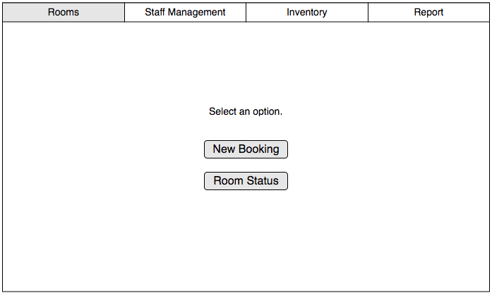

Room Booking

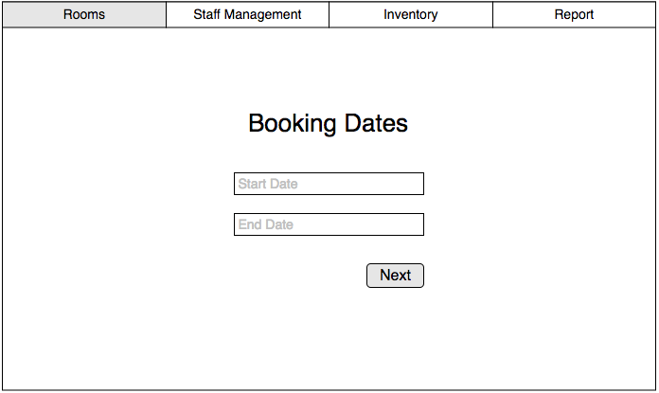

Room Type

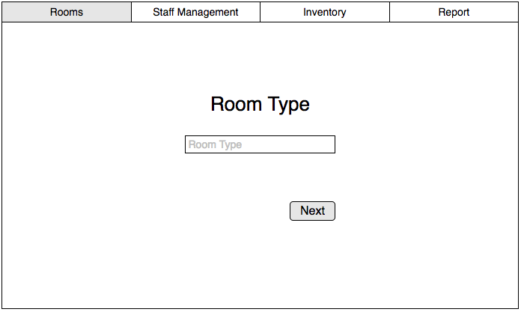

Room Availability

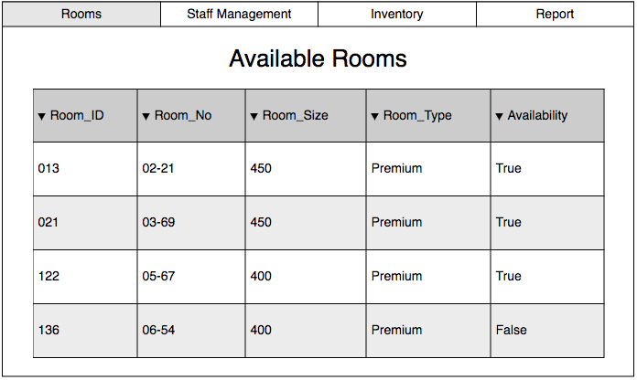

Staff Management

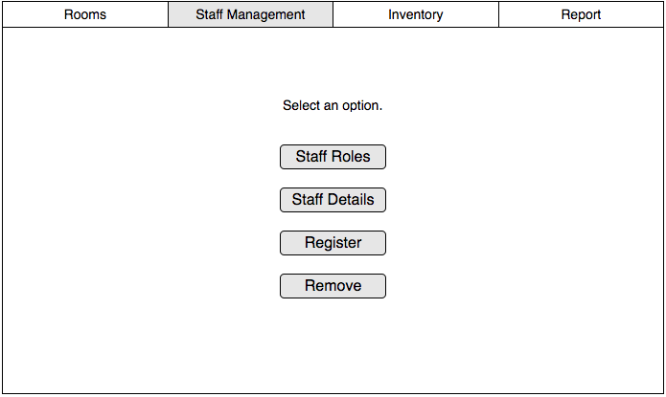

# Staff Registration

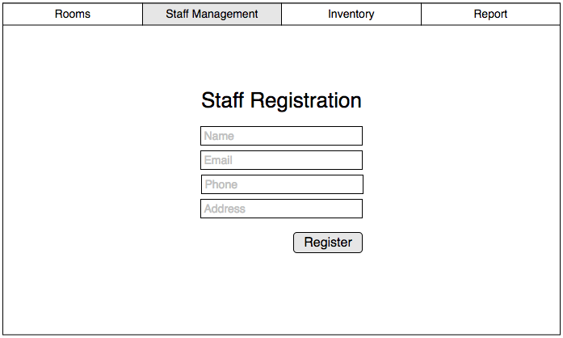

Staff Removal

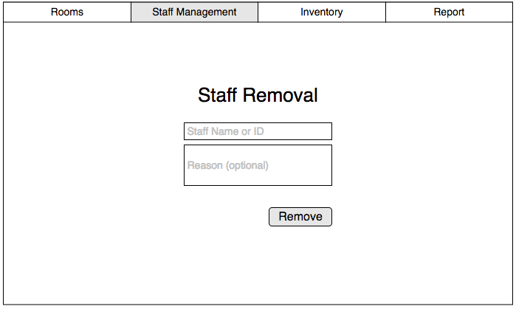

Staff Roles

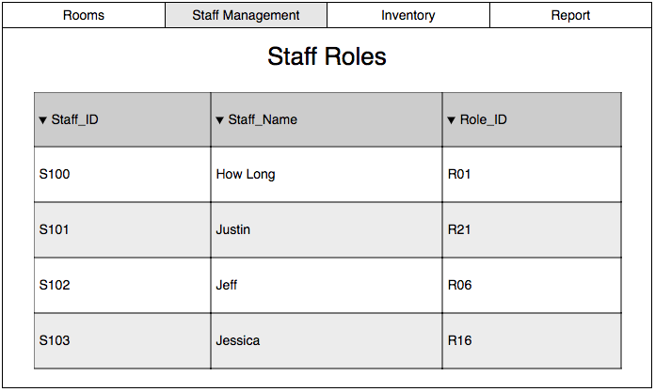

Staff Details

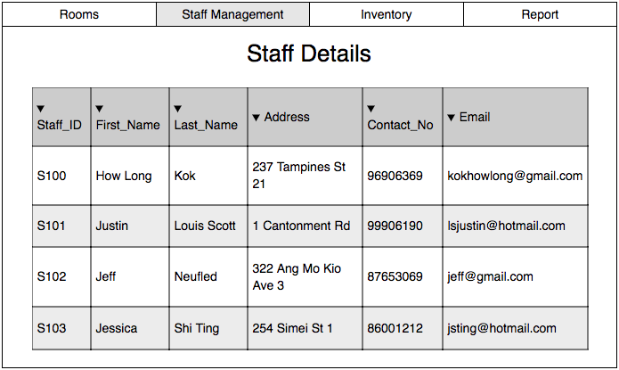

Inventory

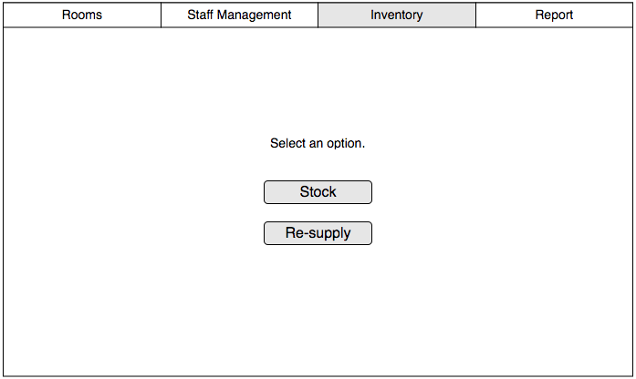

Inventory Stock

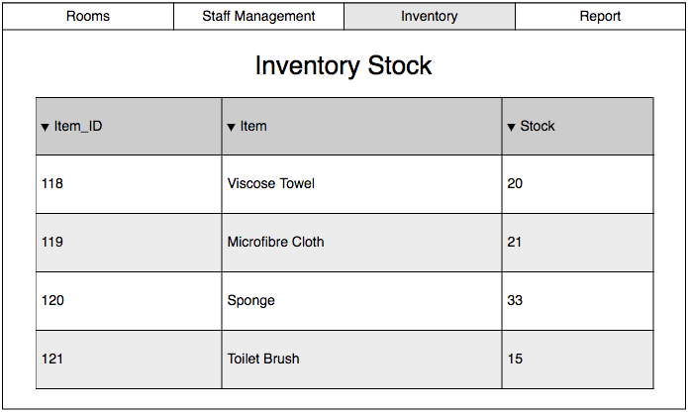

Re-supply Items

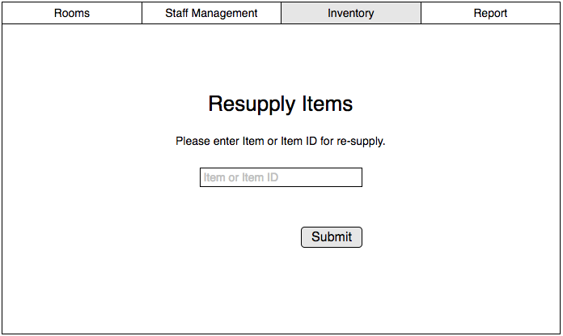

Report

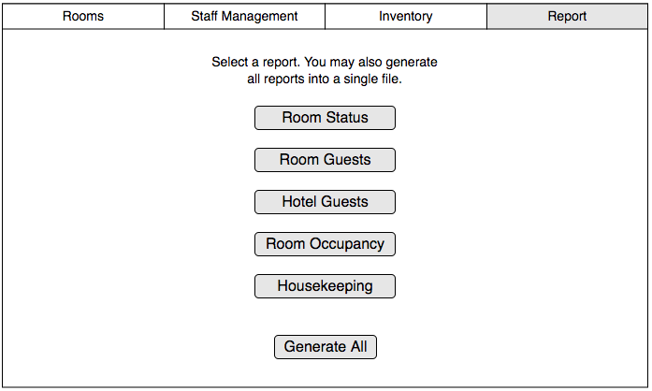

## **Interface with Other Systems**

*[Describe any requirements to interface with other system, either new or existing. List any specification for interfacing and the required data format for communication between the systems. Include any security considerations for such data transfer. ]*

*(Briefly talk about whether your system needs to be connected to any other system)(E.g. Online Reservation System, I ask a third party like booking.com to book for me, and then ask them to send the data over to me and use it from there)(The hotel management system is a stand-alone application. Therefore it is not applicable)*

As the software is self dependent and will only be running on one computer on a local broadband and software, no additional systems will need to be integrated into the software.

## **Assumptions**

*[Record any assumption made or implied regarding the requirements you have gathered for the system.] (Payment will be made during checkout/ Payment will be made once customer reaches the front desk)*

* Payment will be made at the reception counter when the guests checks out from the hotel.
* Invoice will include hotel bills and mini-bar purchases.
* Guests always check out before 12pm.
* Cleaning staff will always check the rooms if the guests have consumed food or drinks from the mini-bar.
* Only the reception staff will be using the software.
* Reception staff will enter guest’s details instead of the guests.
* The hotel has less than 1000 rooms.

# **OPERATIONAL AND QUALITY REQUIREMENTS**

## **Operating Environment**

*[Describe the actual operating environment that the system will be deployed.]*

*(Install what server? What kind of environment do we need to deploy this project)*

*(E.g. A computer with Windows 7, IE, Internet Connectivity)*

**Hardware**

* Pentium 4 Computer 1GB RAM, monitor, keyboard, and mouse
* The computer only has a 1 gigabyte random-access-memory (RAM) and a 160 gigabyte hard disk storage.
* The computer is connected to the internet via a broadband connection.
* The computer is located at a reception counter where the staff of the hotel will be using the system.
* A laser printer will be needed to print reports and notes.
* An additional database server will be added to run the hotel management system

**Software**

* The system will only be deployed on an old computer running on Windows XP Service Pack II.
* Software is designed to run on any platform above Microsoft Windows Service Pack 2
* Microsoft .NET Frameworks 4.0 or above
* Microsoft SQL Server Management Studio Express 2010

## **Development Constraints**

*[List any constraints that are given during the development of the system. (e.g. schedule, platform, etc.). ]*

*(Copy and Paste from TOR)*

**Group Constraints**

* Members have different schedules and therefore may not be able to meet as a group to update on each other’s progress.
* The project is to be finished in eight weeks.
* Due to the hotel not doing well, the budget for developing this project might be constrained.

**Module Constraints**

**Room availability and Booking Module**

* This module is constrained in a sense that records may only be altered manually. This module is not autonomous and records may differ.

**User Creation and Login Module**

* This module is constrained as only the administrator can perform user account and creation for end users and management users.

**Housekeeping and Staff management module**

* The records of the staff need to be manually filled out and also updated manually as and when necessary changes need to be made.

**Reporting Module**

* Report generation is based on data that is manually registered and thus may be prone to human error as a result.

## **Performance (Optional, if we have time try to write response time for each button on the UI for the** hotel system)

*[List the acceptable system response time for each function during time of operations; on the average and during peak hours.]*

*(What is the design performance of the system) (Make it logical, E.g. Google.com response time must be very fast) (Relatively small hotel, response time can be slow.)(E.g. Searching for a room will require 3 seconds before returning results as we are using cheap technologies and cheap hardware)*

The performance of the system will not be as efficient as more popular services such as Google.com as the software will be developed using cheaper technologies and hardware, partly due to the limited budget. As such, the response time of the system can be slow. For example, searching for a room will require at least 3 seconds before the results are returned. Therefore, while the response time of the system is not as fast as Google.com, since Delonix Regia is a relatively small hotel, the longer response times should not be a major issue while running the software.

The acceptable response time for each page of the room booking process is 2-4 second on average and 2-3 seconds during peak hours.  
  
The acceptable response time for the checking of room availability function is 2-4 seconds on average and 2-3 seconds during peak hours.  
  
The acceptable response time for the housekeeping and staff management function is 2-5 seconds on average and 2-4 seconds during peak hours.  
  
The acceptable response time for the reporting function is 2-4 seconds on average and 2-3 seconds during peak hours.

## **Availability**

*[State the system availability requirements e.g. the system is required to run 24 by 7 or the system is required to run during normal working hours (8am to 6pm) from Monday to Friday. State also the acceptable downtime for maintenance and data backup. For example, 2 hours per week. ]*

The system will be running 24/7 for 365 days, unless there are any major renovations to the hotel.

Regular backups can be done early morning from around 2am to 3am daily. Major backups can also be done on the first Sunday of each month. Backup records are to be kept and archived for 5 years.

## **Security and Access Control Requirements (Access Contro**l is a different table)

*[Specify the user groups that can have access to the respective functions and the user locations (if this is a distributed system). Specify user authority to facilitate control over system access and data access. Identify any log required for audit purpose. List any other security requirements such as data encryption or authentication. ]*

*(Which user can use what functions/modules using a table)(Can bluff people, using 2FA, etc.)(Can try to copy and paste from ESAM)*

*(Create a table, E.g. Booking Reservation, Reception, Management, Administrator)*

**Security Table**

|  |  |  |
| --- | --- | --- |
| **Name of Security** | **Description** | **Example** |
| 2FA (Two Factor Authentication) | An extra layer of security that is known as "multi factor authentication" that requires not only a password and username but also something that only, and only, that user has on them, i.e. a piece of information only they should know or have immediately to hand - such as a physical token. | E.g. Scenario when guests purchases room service. 2FA is used to confirm this purchase. |
| E-Mail Verification | E-Mail Verification will be used to verify the guest's account once their account has been created. | E.g. Scenario when guests complete their booking at the front desk, front desk staff will require users to check their e-mail using their phones in order to verify account creation. |
| E-Receipt | E-Receipts will be issued to charge guests on rooms services, culinary services, booking of facilities (suite rooms). This is done as when the guest checks out, the guest can use the E-Receipt as reference for payment purposes. | E.g. When guests checks out of hotel, they are able to compare the prices of the services they have used with the invoice issued to them at the end of their stay. |
| CAPTCHA |  |  |

**Access Control**

|  |  |  |  |
| --- | --- | --- | --- |
|  | **End Users (Reception)** | **Management Users** | **Administrators** |
| Login/Logout | ✓ | ✓ | ✓ |
| Room Availability and Booking | ✓ | ✓ | ✓ |
| Housekeeping and Staff | ✓ | ✓ | ✓ |
| Report Generation |  | ✓ | ✓ |
| User Account and Creation |  |  | ✓ |

# **SPECIAL REQUIREMENTS**

*[Any other requirements that are not included in the above headings, like data archival, etc.] (-NA-)(Say there's no special requirements)*

One of the requested special requirement of the software is the ability for guests to be able to inquire about the room availability of the Delonix Regia hotel online.

Another additional special requirement of the software is the ability for the generated reports from the Reporting Module to be exported to Microsoft Excel and previewed before printing.

# **REFERENCES**

*[List any books or web site that you have used when preparing this requirement specification.](Whatever references you have) (APA everything)*

It All Starts with Your Stunning Website. (n.d.). Retrieved from

<https://www.wix.com/>

What is 2FA? (n.d.). Retrieved November 13, 2017, from

<https://www.securenvoy.com/two-factor-authentication/what-is-2fa.shtm>